# PELMS_ENCLOSURE – Technical Notes

16 May 2024

## Goals

* *Recommendation 2: Develop a more portable and secure enclosure* – the PCB is being developed so that it can be placed in 142 x 110 mm enclosure,

## Construction Notes

* HB6248 - Sealed Polycarbonate Enclosure 171 x 121 x 55 - Clear Lid
* Made with Polycarbonate material and moulded in light grey.
* Operating temperature: minus 40C to 125C
* The lid and base incorporate a tongue and groove sealing system with an EPDM gasket
* Lid fixing screws are M-4 stainless steel (non-metallic) into threaded brass inserts
* Wall mounting holes and lid fixing screws are outside the sealing area thus preventing the ingress of moisture & dust
* Designed to IP65 of IEC 529and NEMA 4 (dust and hose proof)
* Internal guide slots for mounting PCB assemblies vertically
* External mounting plate (4pcs) made of thermoplastic are available as an option
* External hinge kit (2pcs) made of thermoplastic are available as an option.

## Parts List – 24 April 2024

|  |  |  |  |
| --- | --- | --- | --- |
| Part | Supplier  Part Num. | Product  Description | Notes |
| Sealed Polycarbonate Enclosure 171 x 121 x 55 - Clear Lid | Jaycar  HB6248 | See Part | Preferred enclosure to use.  AUD $29.95 |
| Sealed Polycarbonate Enclosure 171 x 121 x 80 | Jaycar  HB6224 | See Part | Enclosure that can be used if more space is required.  AUD $31.95 |
| 6mm Untapped Nylon Spacers - Pack of 25 | Jaycar  HP0930 | See Part | Clearance hole 4.1mm.  OD 6.4mm.  Pack of 25 untapped nylon spacers.  AUD $7.95 |
| M3 x 6.3mm Tapped Nylon Spacers - Pack of 25 | Jaycar  HP0920 | See Part | AUD $9.95 |
| 3mm Nylon Washers - Pack of 10 | Jaycar  HP0148 | See Part | Corrosion proof precision fixtures and hardware suitable for high temperature applications.  AUD $2.95 |
| M3 x 15mm Steel Screws - Pack of 25 | Jaycar  HP0406 | See Part | AUD $3.95 |
| 30 Amp Car Battery Type Clips - Pack of 2 | Jaycar  HM3012 | Alligator or Crocodile style battery clamp for positive and negative terminals. Sold as a pair. All have insulated colour coded handles. 1 Red & 1 Black. | AUD $5.95 |
| 3-6.5mm DIA Waterproof Cable Glands - Pack of 2 | Jaycar  HP0720 | See Part | AUD $5.95 |
| Panel Mount Holder for Single Anderson Powerpole PP15/PP30/PP45 PP15/45 15/45 | ezypowerbox (via ebay) | See Part | 3D printed part made available from <https://ezypowerbox.com.au/>  and was purchased via ebay.  AUD $9.00 |
| Aluminium Sheet - 295 x 295mm - 18-guage | Jaycar  HM9500 | See Part | Cut to PCB size for heat sink.  AUD $20.95 |
| CSE-SGAM-305-SGFB  (SMA Cable Assembly) | Digikey  343-CSE-SGAM-305-SGFB-ND | Cable Assembly Coaxial SMA to SMA RG-316 12.00" (304.80mm) | AUD $10.16 |

## PCB Enclosure Diagram and Schematics

**Figure 1: (Shown next page) Enclosure Dimensions**

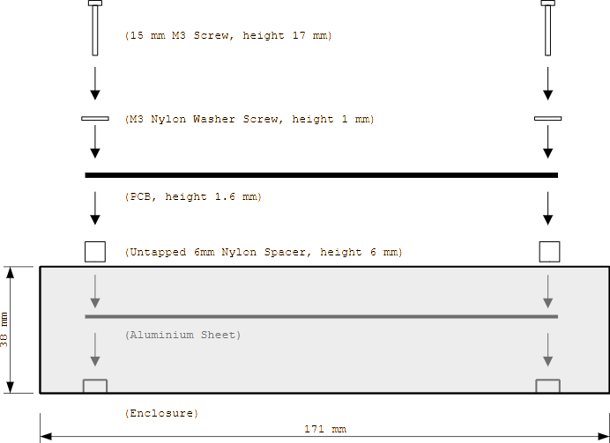

**Figure 2: Side Assembly View**

